ETL And OLAP Tool Usage
Introduction
Data warehousing projects rely on tools that help in extracting, transforming, loading (ETL) data and then analyzing it (OLAP) for decision-making. The two main categories of tools are:
- ETL Tools: Help in integrating data from multiple sources into a centralized warehouse.
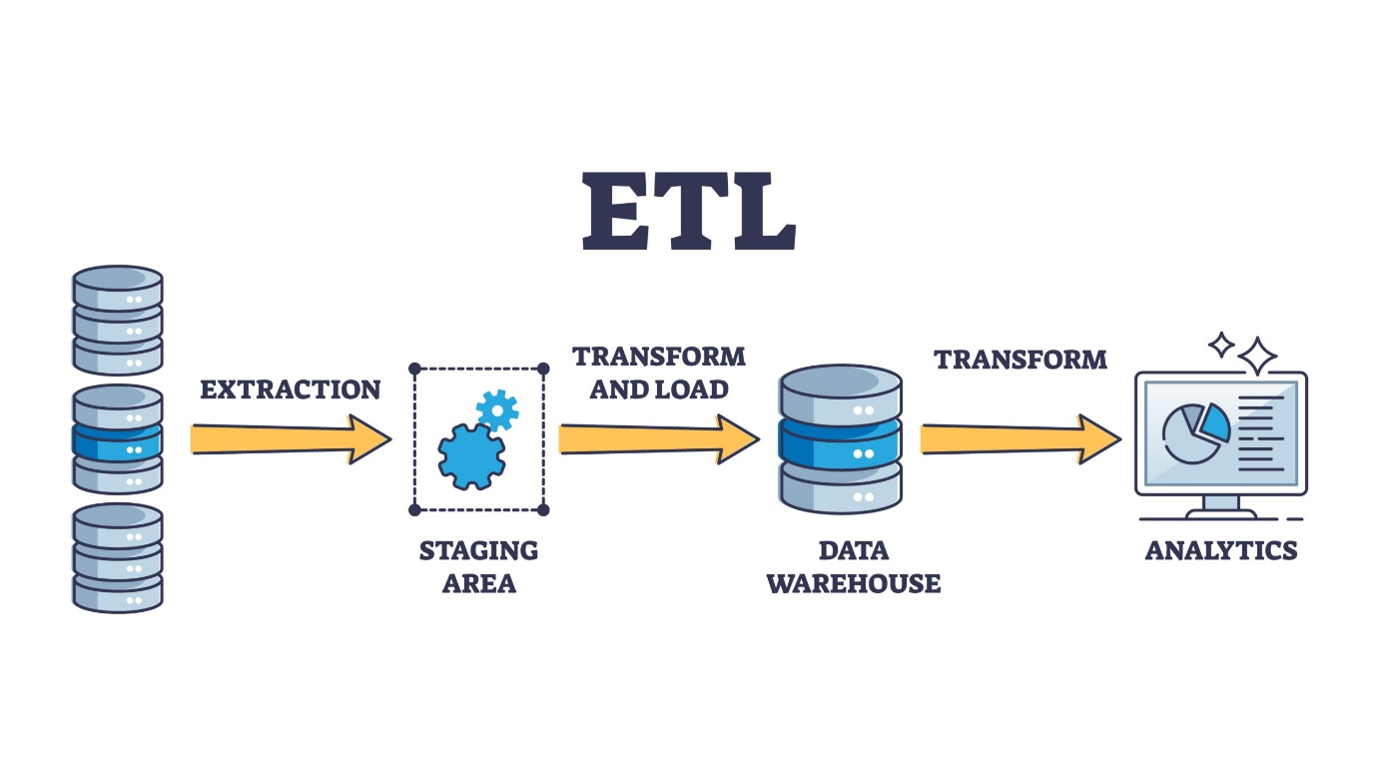
- OLAP Tools: Enable users to analyze, visualize, and generate actionable insights from warehouse data.
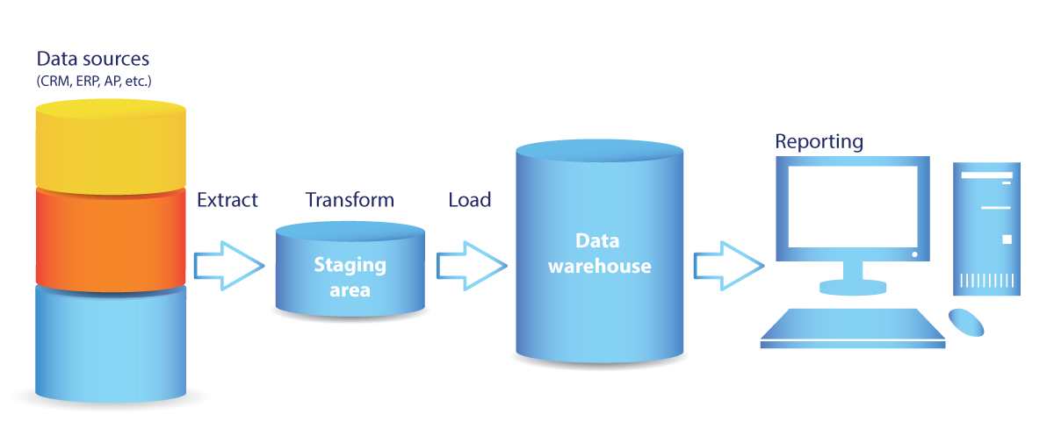
In this assignment, we focus on Talend Open Studio (ETL) and Microsoft Power BI (OLAP).
Tool Identification
Tool Name | Type
Apache wifi | ETL Tool
IBM Cognos TM1 | OLAP Tool
1. Apache Kylin (not “Apache WiFi”)
Apache Kylin
Apache Kylin is an open-source OLAP tool used for big data analytics.
- It is designed to run on Hadoop ecosystem
- Provides very fast query performance on large datasets
- Uses pre-built cubes (multidimensional data models) for quick analysis
- Helps in analyzing data using SQL queries even on huge data
Function Explanation
ETL Tool – Talend Open Studio
- Extract: Collect data from multiple heterogeneous sources (databases, spreadsheets, CSV, JSON, APIs)
- Transform: Clean, normalize, and format data to ensure accuracy and consistency
- Load: Insert transformed data into the target data warehouse for further analysis
OLAP Tool – Power BI
- Provides a multidimensional view of data using data cubes
- Allows users to filter, sort, and drill-down data for detailed insights
- Generates interactive dashboards and reports that support decision-making
- Example: In a college project, Power BI can show top-performing students, subject-wise performance, and attendance trends

Concept Mapping
ETL and OLAP tools work closely with computer system resources. Mapping them to OS / computer concepts helps understand their functioning:
ETL Tool – Talend Open Studio
Concept | Mapping
Memory | Temporary storage of data during extraction and transformation
CPU | Processing transformations and calculations on large datasets
Storage | Loading processed data into the centralized data warehouse

OLAP Tool – Power BI
Concept | Mapping
Data cube | Provides a multidimensional view of data for analysis
CPU | Handles query processing for reports and calculations
Memory | Caches dashboard data for fast visualization

Explanation:
• Talend ensures data quality by removing duplicates, handling missing values, and standardizing data formats before loading into the warehouse.
• It can handle large volumes of data efficiently using parallel processing, which improves speed and performance.
• Power BI allows users to interact with data through filters, slicers, and drill-down features for deeper analysis.
• It provides real-time insights by automatically updating dashboards when new data is available.
• Both tools help in better decision-making by converting raw data into meaningful and structured information.

Practical Relevance
Talend Open Studio (ETL)
- Hospitals: Combine patient records from multiple departments to get a complete profile
- Banks: Merge transaction data from different branches for fraud detection
- Colleges: Integrate student marks, attendance, and semester data for performance analysis
Microsoft Power BI (OLAP)
- College Dashboards: Display subject-wise performance, attendance, and top performers
- Sales Dashboards: Track product trends, revenue, and customer analytics
- Hospitals: Analyze patient data, treatment outcomes, and department performance
Project Example
- In an Academic Performance Data Warehouse, Talend extracts and transforms marks from multiple semester files into a unified format.
- Power BI visualizes trends, identifies top students, and shows subject-wise performance using interactive dashboards.

Documentation / Presentation
• ETL and OLAP tools play an important role in data management and analysis.
• Talend Open Studio helps in collecting and preparing data from multiple sources.
• Power BI helps in analyzing the processed data and creating meaningful reports.
• Together, these tools help organizations to make better and faster decisions.
Thus, ETL and OLAP tools convert raw data into useful insights.

